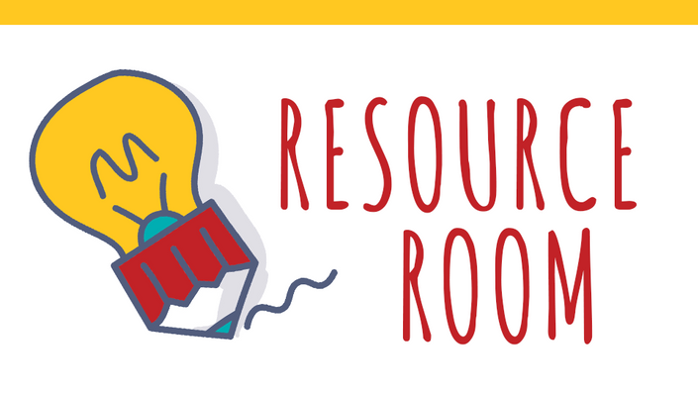

Resource Room Guidelines

2018-19

Mrs. Lohmeyer

**Purpose:** Resource room is a time during your school day where academic support is provided. Individual or small group instruction will help to reinforce curriculum in your academic classes. Topics that may be addressed include:

* Vocabulary development
* Organizational skills
* Reading comprehension
* Test-taking strategies and study skills
* Career and transition planning
* Writing skills

**Goals:**

* Reinforce and provide assistance with academic class content.
* Work on IEP goals and objectives.
* Provide testing modifications, as needed.

**Assessment Procedures:**

Progress report and report card comments are given based on student effort. I will also be in touch on a regular basis with content area teachers regarding work progress, upcoming projects and assignments, and any difficulties the you may be experiencing.

**Student Responsibilities:**

* Students are expected to bring their daily homework/materials from their content area classes.
* Students are to be on time to class.
* Students should be prepared to work with all the proper materials such as pens, pencils, and paper.
* Cell phones are permitted to look up class assignments,use websites, and to use study sites such as Quizlet. Phones are not allowed to avoid doing work. Consistent misuse of phones will result in a ban on using them at all.
* If you are up to date on work then students are to get their resource room folder which contains supplemental materials.

**Contact Info:**

**Office:** Room 113  **email**: [elizabeth.lohmeyer@wcsdny.org](mailto:elizabeth.lohmeyer@wcsdny.org)

**Schedule:**

Period 1: ELA 10 rm 103

Period 2: ELA 12 rm 206

Period 3: ELA 10 rm 105

Period 4: lunch

Period 5: ELA 12 rm 206

Period 6: Resource Room rm 210

Period 7: duty

Period 8: prep